Shaler Soccer Club
Annual General Meeting
11/12/20 6:30pm – 8:14pm
AGENDA

Call to Order – 6:30 PM – Nick Druga

Welcome and COVID recap
- Not where we thought we would be or what the season would look like this year.
- Thank you to the commissioners, the unsung heroes of our COVID details
Reading of the Minutes of the last General Meeting - Acceptance of those Minutes - Motion – Jim Marsula, Second – Amanda Fine, All AYE – Meeting minutes accepted
Reading of the Annual Reports
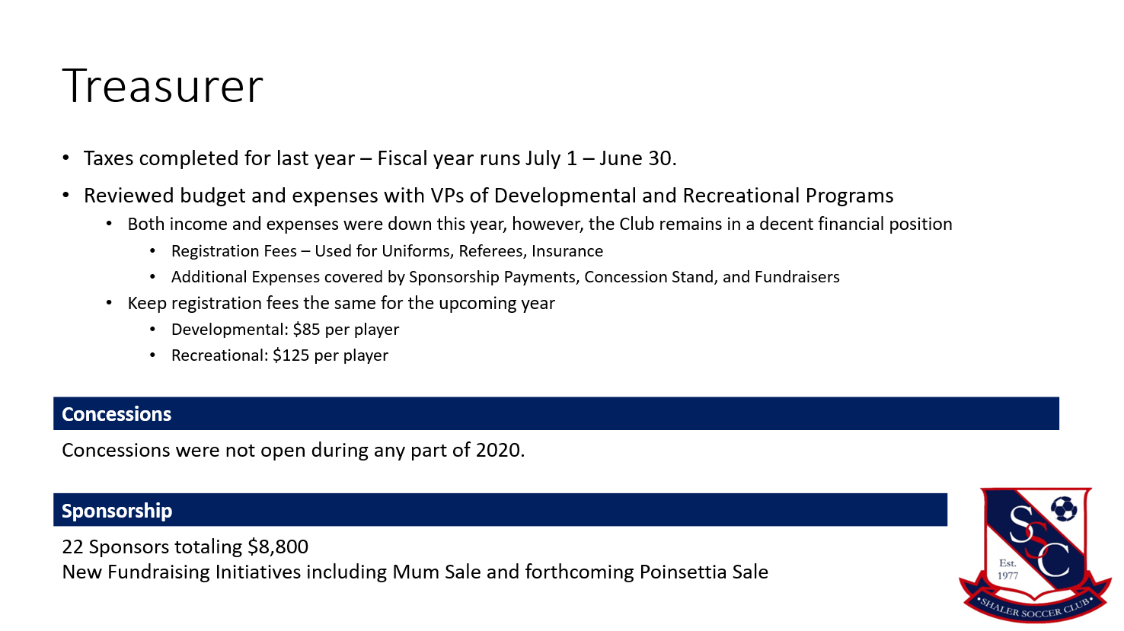
- Treasurer – Stacy Schmidt
  - Thank you to club members and parents
  - Completed taxes for last year (July 1,2019 through June 30, 2020)
  - Income down this year due to no Spring Season
  - Registration fees will remain the same
  - $85 for developmental
  - $130 for recreational 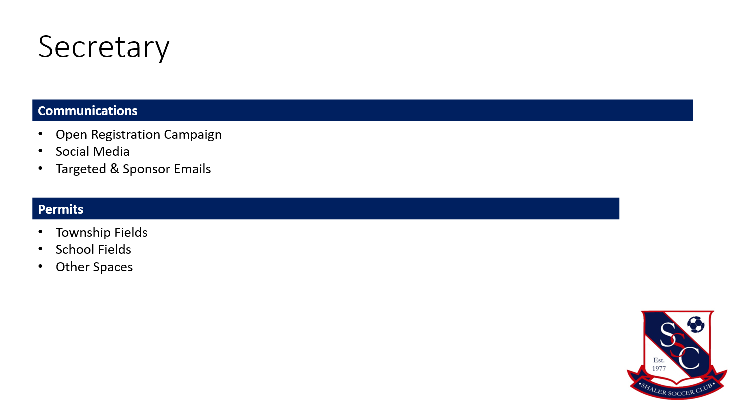
- Secretary
  - Recap of
  - Communications – additional communication, increased social media presence, and increased communications to the group
  - Township fields – Denny, Fall Run, Fawcett and Glenshaw Valley

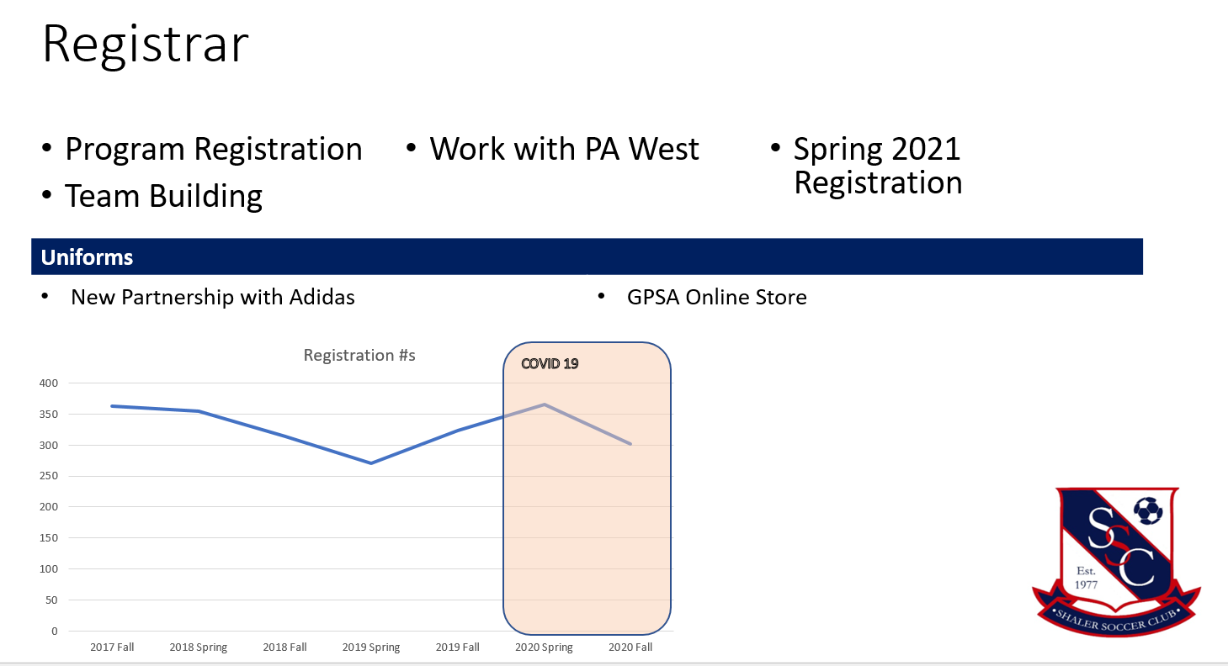
- Registrar
  - Managed to have 34 teams – all well balanced
  - Thanks to the many volunteer coaches to allow us to have the teams
  - Partnering with Adidas for uniforms through GPSA – getting funds to support the club in other items that the club would need
  - GPSA store – will have another store during the Spring
  - Question – Year Round uniforms – not able to Spring 2021, potential for Fall 2021
  - Question – Logo change – support? To address in the Spring

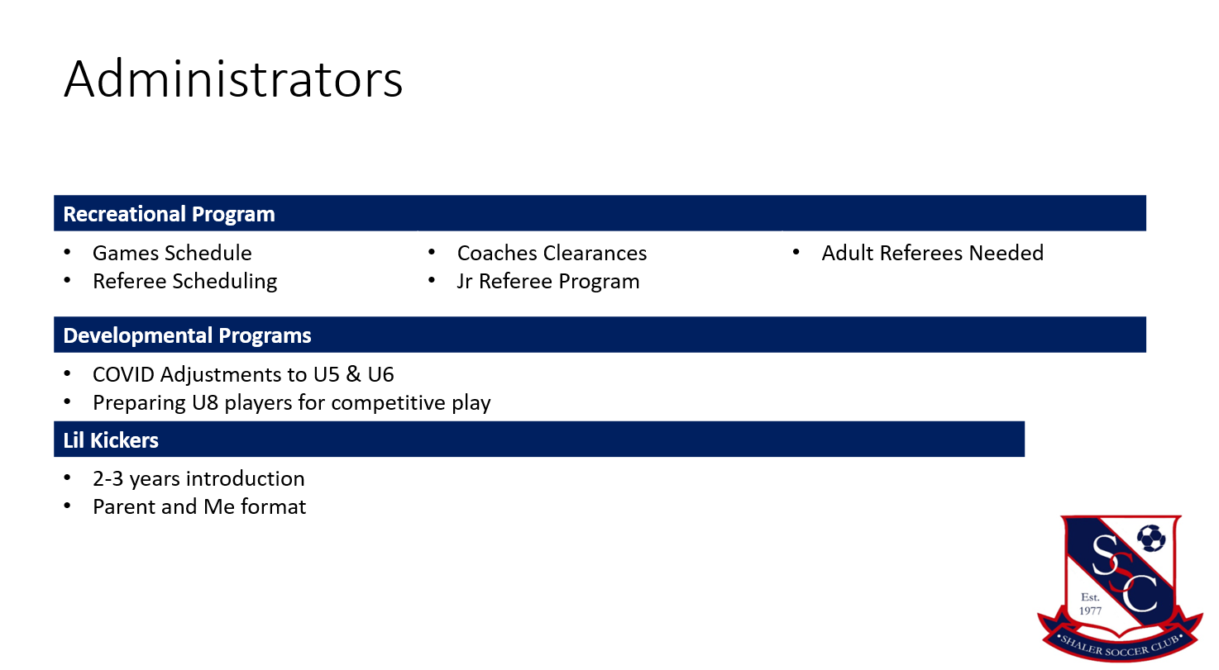
- Recreational Program – Courtney Bianchi
  - Clearances and Licensing for all recreational coaching
  - Game scheduling and referee scheduling
  - New Jr. Referee program
    - 20-30 kids that completed 2 sessions of training offered through the club
    - Continuing to expand the training in 2021
    - Need Adult referees – will forward information as needed

- Developmental Program – Julie McDermott
  - Jr. Referee program implemented in the U8 program
    - Provide structure for the U8 players to get ready for U10
    - Young referees getting experience and confidence
  - U5/U6 successful season
    - Opened up the field with the changes to COVID details
    - Parents really supportive of the needs/changes
  - Little Kickers – U4
    - Disrupted due to COVID
    - 15 players grew to 30 for the Spring ‘20, but not as many for the Fall Season due to moving up to U5
    - New players
    - Parent and Me format – masked at all times
    - 8 players participated
  - No concession stand this year
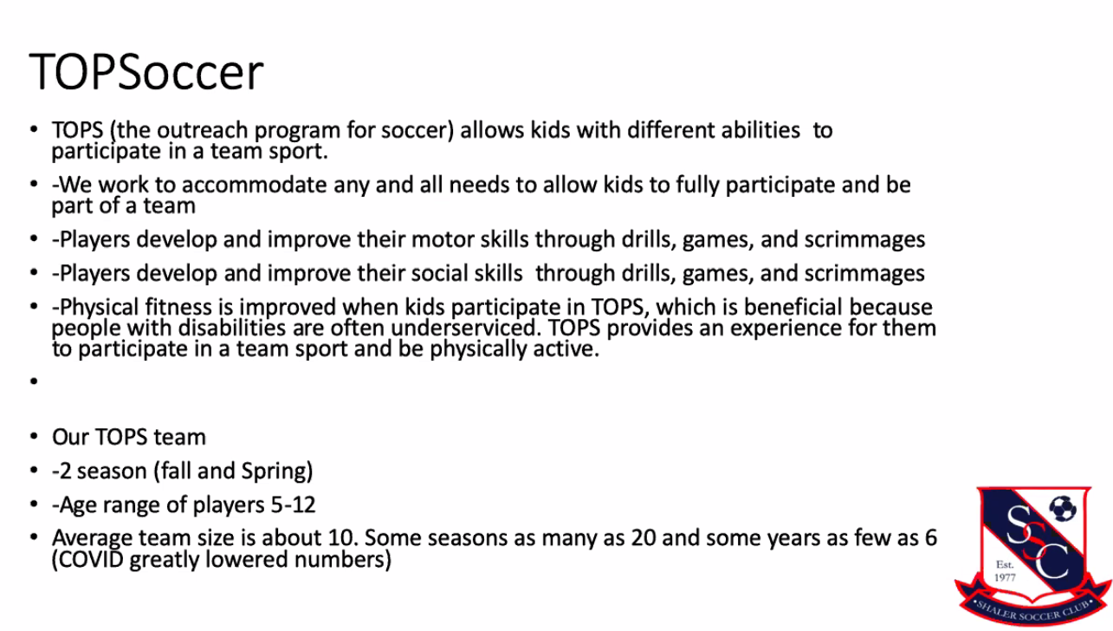
- Anyone interested in volunteering, sign-up to build the TOPSoccer program

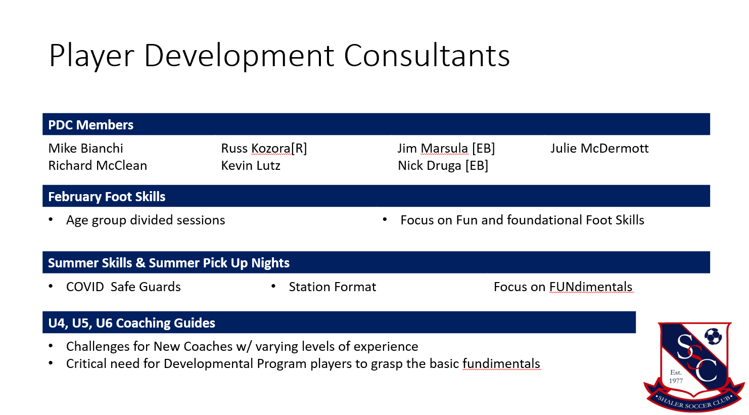
- PDC – Mike Bianchi
  - Thank you to the development consultants –
  - Special thank you to Russ Kozora – made kids passionate about soccer
  - February Foot Skills
  - Excellent job first go around
  - Fees were low – school was free to use
  - Another chance to grow SSC
  - Su
- Secretary's report - Jamie Stromoski
    - Take notes, plan picnic, and uniforms.
  - Summer Skills and Pick-up Nights
  - Want everyone to gain confidence – the #1 skill to pick up
  - All around confident teammate
      - Late players have been a stuggle as we try to allow more kids to play
  - Jr. Referee Program
  - Largest group taught by Mark
  - Understanding the aspects of the game
  - COVID impact may not have Winter Footskills
    - Successful
  - U4/U5/U6 Coaching guides
    - Met a few weeks ago and moving to different layout to coaches manuals
    - Many coaches this year came out with little experience
    - Some tasks worked well, some were a challenge
    - What do you need to be successful in a Soccer Match?
      - Working with PC and Dave Flavius to develop basic/core principles
      - Identify skills that are needed to develop
      - Make it simple and give coaches some additional freedom to develop based on kids and more user friendly
      - Working on the focus points – 1 soccer idea at a time
  - Early Registration – Fall
    - Everyone that signed up was able to train with the members of the PDC
    - Get the teams started early to make a biggest impact to the club
    - Try to expand on that this year
  - Use the PDC – there is a lot of knowledge on the team
  - All great opportunities to get parents involved to learn/watch for experience to allow you to become a coach
  - Winter Foot Skills to be announced soon!

- Unfinished Business – None.

- Vice President Report – Jim Marsula, Recreational
  - Normal process is to have a draft with coaches
  - Seasons seems long, but really is only 8 weeks of games and 3 weeks of practice
  - Possibility of keeping the teams matched up and kids together
    - Main goal is to prepare the players for Middle School and High School when they play together
    - Can be challenging in the Fall season due to School season
  - Evolve our player evaluations
    - Expanded on the A,B,C,D to 1 through 5
    - The goal is to get more consistent and accurate ratings to support the team building process
    - Used to have D4 team (Highest level of community club competitiveness)
    - Want to get back to higher competitiveness – year long commitment to keep the teams together
    - Lost classic club players due to competitiveness
  - Fields were tricky this year due to COVID
    - Rotated the fields to eliminate wear patterns
    - Referees did complain previously due to wear (1.5 years ago)
    - Spread out fields to allow for U8 fields to be spread out to be supportive of the COVID impacts
  - Question – Field upgrades
    - Grants availability for upgrading turf
    - Millvale Field - ?
  - Competitive teams – Board make the decision
    - PDC involvement? Big part of the decisions is making the team and criteria for the team building
    - Tryouts/Coaches? PDC will certainly be involved with (Ricky)
    - Want to have a place for all the kids to play – whether they want to just have fun or if they are really interested in being competitive
    - Board will vote on the final procedures
    - Whoever wants to sign up for the year round team, build the chemistry, etc. want to play – not just the 5 rating kids on one team
    - Not putting the kids in the most competitive level (D4), but the putting the kids
  - Question: Is there a possibility for a year round training, no matter the rating level, to allow them to play year round to grow?
    - We are continuing to introduce additional programs – Winter foot skills, summer foot skills, Complete Moves
    - Continuing to try to offer the programs to support year round learning
    - Shaler Soccer Club Futsal program – winter futsal team; a 3rd season

- Vice President Report – Amanda Fine, Developmental
  - Push to get more kids signed up in the Spring and got it, but COVID
  - Numbers down for the fall a little, but still good even with COVID
  - COVID impact – temperature checks, hand sanitizer etc.

- Vice President Attestation for the Budget Audit – 7:40 PM
  - Amanda – Validated
  - Jim – Validated
  - Had Skype call to validate all budgeting

- President’s Comments – Nick Druga
  - Coaching Surveys – put the questions out there (same questions for the coaches at all age levels)
    - Net Promoter Score (9-10 Promoter, 7-8 Neutral, 1-6 Detractor)
    - % of 9/10 vs. 1/6 %
    - Nick can provide coaches scores/surveys, if they are wanted
    - Continue to work with the PDC
  - Coaches Scores – 100 Net Promoter Score and ½ of the team’s player responses
    - Recreational Awards
      - U10 – Rios, Druga, Caporusio
      - U12 – Bianchi, Marsula, Crider
    - Developmental Awards
      - U8 Mitchell
      - U5 Claus
  - Season Ending Survey

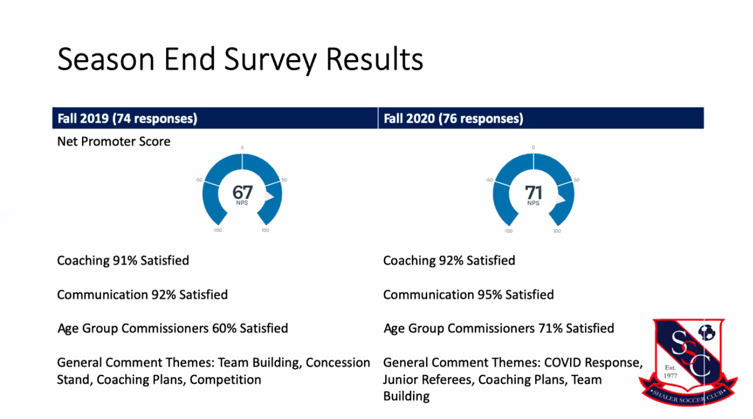

- Community involvement
  - Boys and Girls club
  - North Side donations – clothing, food and soccer balls
  - Community support with the Etna Fire, Millvale Flooding
  - Kids feel like they are part of a family with their team
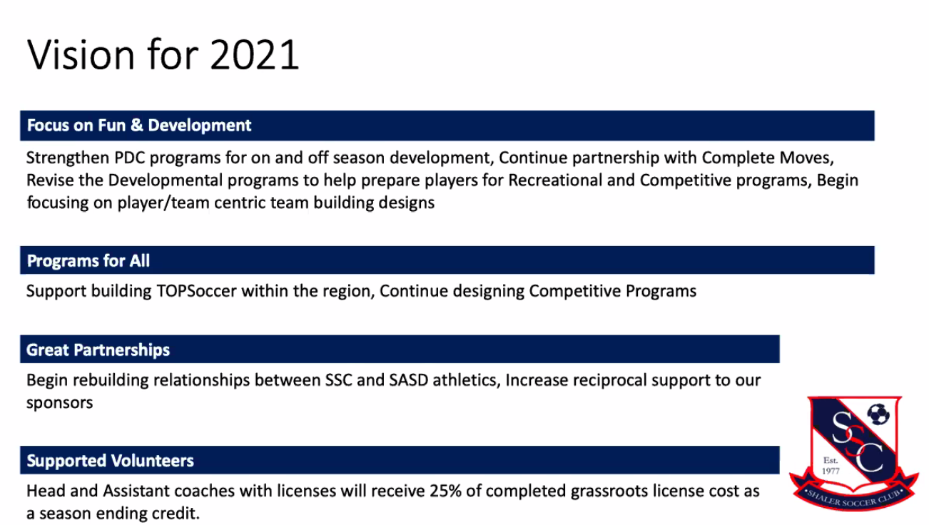

- Vision 2021 – some repurposed ideas, didn’t quite have the 2020 we expected
  - Focus on Fun and Development
    - PDC for additional off season development
    - Partnership with Complete Moves
    - Revise the Developmental programs to prepare players for more competitive play
    - Continued focus on the player
  - Programs for All
    - Continue TOPS Soccer and grow
    - Lil Kickers, U5/U6
    - Develop competitive programs
  - Great Partnerships
    - Rebuild partnership with SASD athletics – Athletic director and soccer coaches
      - Mike Bianchi – working to rebuild the relationship
      - Middle school connections with the girls side
      - Working with the Boys side and our coaches
    - Futsal program development
    - More reciprocal support for our Sponsors – sponsor spotlight, support in the community, strengthen the community
  - Supported Volunteers
    - Submission of player evaluations – 25% of the grassroots license cost as a season ending credit

- Nominating Committee Chair's Report – Amanda Fine, Kate Koch, Stacie Schmidt
  - Executive Board – all approved tonight
    - Nick Druga - President
    - Amanda Fine – VP In House, Developmental
    - Jim Marsula - VP Travel, Recreational
    - Kim Rios – Registrar
    - Kate Koch – Secretary
    - Stacie Schmidt – Treasurer
  - Members at Large
    - Harold Schmidt – interest in permits
    - Jason Quinn – interested Field Manager
    - Julie McDermott – interested Commissioner Coordinator
    - Aime Harrison – interested Communications
    - Jamie Renda – interested Communications/Sponsorship
    - Chris Lemke – interested Concessions, Communications
    - Courtney Bianchi – Travel Admin
    - Jen Herman – Concessions
    - Mike Bianchi – Player Development

Motion to accept executive board as nominated – Motion: Julie McDermott, Second – Jason Quinn
Motion passed

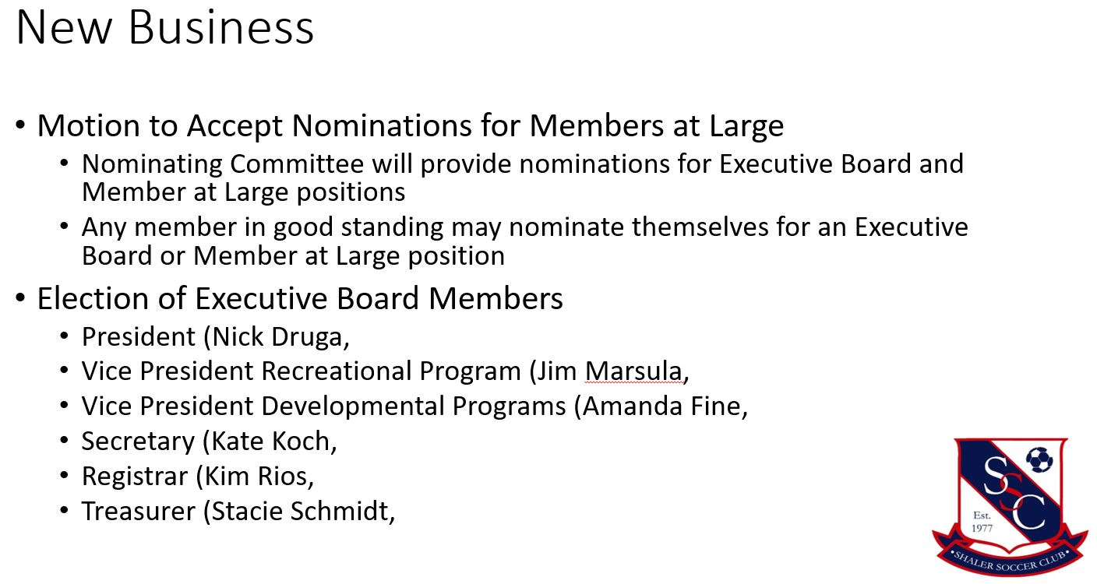

Adjournment: Motion – Jason, Second Amanda, 8:14 PM

